SYDNEY WESTERN CITY PLANNING PANEL

Panel No: | PPSSWC-20.
DA Number: | 2019/573/1.
Local Government Area: | Camden.
Development: | Demolition of existing hard stand areas, services and a car park, construction of a new National Herbarium of NSW comprising a research station and associated site works.
Street Address(es): | 362 and 396 Narellan Road, Mount Annan.
Applicant / Owner: | Royal Botanic Gardens and Domain Trust / Royal Botanic Gardens and Domain Trust and Water NSW.
Date of DA Lodgement: | 26 July 2019.
Number of Submissions: | None.
Recommendation: | Approve with conditions.
Regional Development Criteria (Schedule 7 of State Environmental Planning Policy (State and Regional Development) 2011): | Crown development capital investment value >$5 million.  General development capital investment value >$30 million.
List of All Relevant s4.15(1)(a) Matters: | - State Environmental Planning Policy (State and Regional Development) 2011.  - State Environmental Planning Policy (Infrastructure) 2007.  - State Environmental Planning Policy No 33 - Hazardous and Offensive Development.  - State Environmental Planning Policy No 55 - Remediation of Land.  - Sydney Regional Environmental Plan No 20 - Hawkesbury-Nepean River.  - Camden Local Environmental Plan 2010.  - Camden Development Control Plan 2011.
List all Documents Submitted with this Report for the Panel’s Consideration: | - Assessment report.  - Camden Local Environmental Plan 2010 assessment table.  - Camden Development Control Plan 2011 assessment table.  - Recommended conditions.  - Proposed plans.
Report Prepared By: | Ryan Pritchard, Principal Planner.
Report Date: | November 2019.

Summary of Section 4.15 matters

Have all recommendations in relation to relevant s4.15 matters been summarised in the Executive Summary of the assessment report? | Yes.

Legislative Clauses Requiring Consent Authority Satisfaction

Have relevant clauses in all applicable environmental planning instruments where the consent authority must be satisfied about a particular matter been listed and relevant recommendations summarised in the Executive Summary of the assessment report? | Yes.

Clause 4.6 Contraventions to Development Standards

If a written request for a contravention to a development standard (Clause 4.6 of the Growth SEPP) has been received, has it been attached to the assessment report? | N/A.

Special Infrastructure Contributions

Does the DA require Special Infrastructure Contributions (s7.24)? | No.

Conditions

Have draft conditions been provided to the applicant for comment? | Yes.

PURPOSE OF REPORT

The purpose of this report is to seek the Sydney Western City Planning Panel’s (the Panel’s) determination of a development application (DA) for a new National Herbarium of NSW at 362 and 396 Narellan Road, Mount Annan.

The Panel is the consent authority for this DA as the capital investment value (CIV) of the development is $33,185,538. This exceeds the CIV thresholds of $5 million and $30 million for Council to determine the DA pursuant to Schedule 7 of State Environmental Planning Policy (State and Regional Development) 2011.

SUMMARY OF RECOMMENDATION

That the Panel determine DA/2019/573/1 for a new National Herbarium of NSW pursuant to Section 4.16 of the Environmental Planning and Assessment Act 1979 by granting consent subject to the conditions attached to this report.

EXECUTIVE SUMMARY

Council is in receipt of a DA for a new National Herbarium of NSW at 362 and 396 Narellan Road, Mount Annan.

Pursuant to Section 4.32 of the Environmental Planning and Assessment Act 1979, the development is classed as Crown development as the Royal Botanic Gardens and Domain Trust is a public authority. Pursuant to Section 4.33 of the Environmental Planning and Assessment Act 1979, the Panel can only refuse its consent to a Crown DA or impose a condition not agreed to by the applicant with the approval of the Minister for Planning and Public Spaces. Notwithstanding, Council staff recommend that the Panel approve the DA and the applicant has agreed to the imposition of the conditions attached to this report.

The DA has been assessed against the Environmental Planning and Assessment Act 1979, the Environmental Planning and Assessment Regulation 2000, relevant environmental planning instruments, development control plans and policies.

A summary of the assessment of all relevant environmental planning instruments is provided below with a detailed assessment provided later in the report.

State Environmental Planning Policy (State and Regional Development) 2011. | The Panel is the consent authority for this DA as the development has a CIV of $33,185,538 which exceeds the CIV thresholds of $5 million and $30 million for Council to determine the DA.
State Environmental Planning Policy (Infrastructure) 2007 (ISEPP). | The development is permitted with consent pursuant to the ISEPP. The DA was referred to Endeavour Energy for comment pursuant to the ISEPP and the comments received have been considered.
State Environmental Planning Policy No 33 - Hazardous and Offensive Development (SEPP 33). | The development will not breach SEPP 33’s screening thresholds for the storage of dangerous goods on the site. A condition is recommended that requires the quantities of dangerous goods to be transported to and from the site to be kept below SEPP 33’s screening thresholds. Council staff are satisfied that the development is not hazardous or offensive development as defined by SEPP 33.
State Environmental Planning Policy No 55 - Remediation of Land. | Council staff have assessed phase 2 detailed contamination assessments submitted in support of the DA. Council staff are satisfied that the site is suitable for the development.
Sydney Regional Environmental Plan No 20 - Hawkesbury-Nepean River (SREP 20). | The development is consistent with the aim of SREP 20 (to protect the environment of the Hawkesbury-Nepean River system) and all of its planning controls.
Camden Local Environmental Plan 2010 (Camden LEP). | The development is prohibited in the applicable SP1 Special Activities and SP2 Infrastructure zones by the Camden LEP, however it is permitted with consent pursuant to the ISEPP. The development is consistent with the zones’ objectives and acceptable in terms of the Camden LEP’s other matters for consideration.

The DA was publicly exhibited for a period of 30 days in accordance with Camden Development Control Plan 2011. The exhibition period was from 21 August to 19 September 2019. No submissions were received.

Based on the assessment, it is recommended that the DA be approved subject to the conditions attached to this report.

AERIAL PHOTO

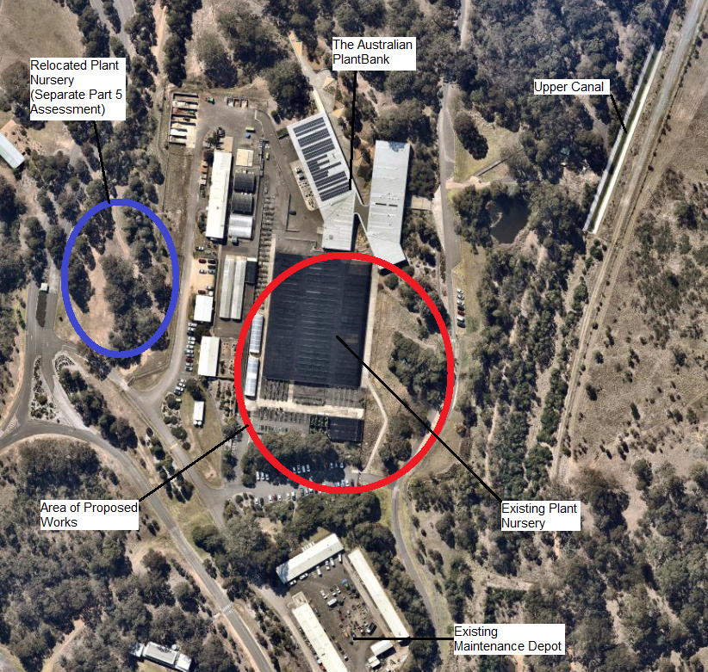

THE SITE

The site comprises two properties that are commonly known as 362 and 396 Narellan Road, Mount Annan and are legally described as lot 132, DP 825469 and lot 1, DP 1191009.

The site contains the western half of the Australian Botanic Garden Mount Annan (the Garden) and the Water NSW Upper Canal (a State heritage item). The exact area of the site to be developed is adjacent to the existing Australian PlantBank facility in the approximate centre of the Garden. This area is located 1.44km from Narellan Road to the north east and 264m from Mount Annan Drive (the nearest public road) to the north west.

The site contains an existing plant nursery, vegetation and part of the Upper Canal property. However, the development will not impact upon the Upper Canal structure with the nearest above ground portion of it being located 85m from the development. Part of the site is mapped as bush fire prone land.

On 13 October 2011 the Sydney West Joint Regional Planning Panel approved a science, conservation, education and research facility (The Australian PlantBank) directly adjacent to the site to the north.

The surrounding area is characterised by the Australian Botanic Garden Mount Annan. The Garden contains undulating hills, lakes, lawn areas, walking tracks, landscaped gardens and existing native vegetation including Cumberland Plain Woodland and River Flat Eucalypt Forest. Also present are several buildings and structures including the Australian PlantBank, a plant nursery, visitors’ centre, restaurant, children’s playground and various shade and seating structures. The Upper Canal winds through the site from north to south.

To the north lies Narellan Road, the Campbelltown Scenic Hills and the residential suburb of Currans Hill. To the east lies the Hume Motorway and the Western Sydney University Campbelltown Campus. To the south lies the rural residential suburb of Menangle Park and the Nepean River. To the west lies the residential suburb of Mount Annan.

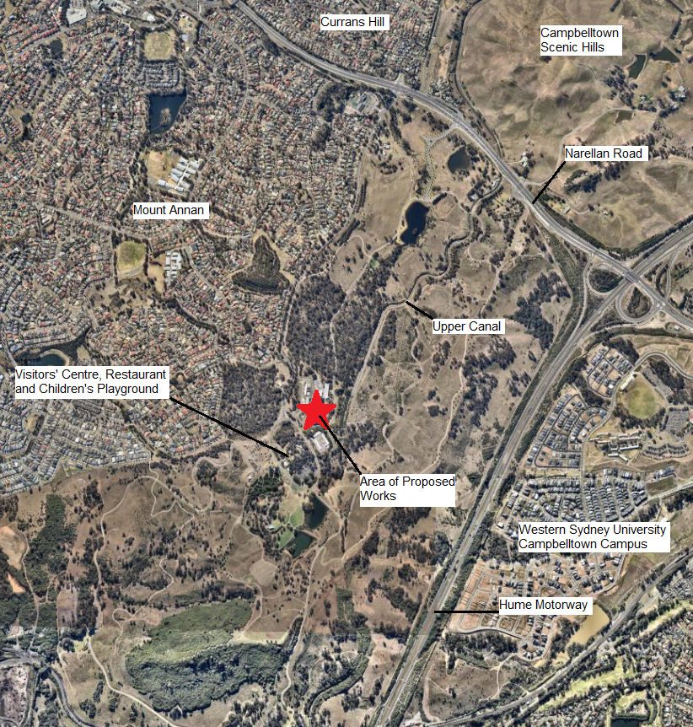

ZONING PLAN

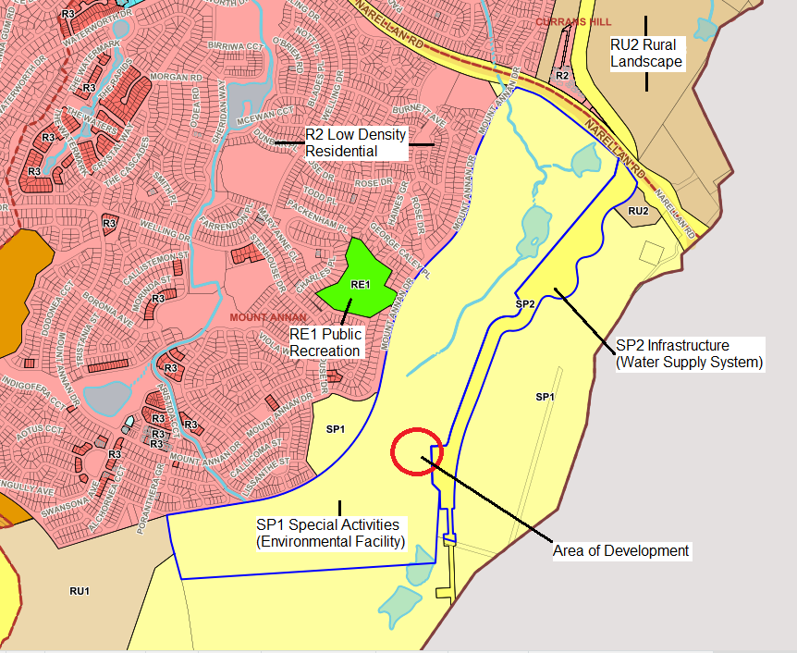

HISTORY

The relevant development history of the site is summarised in the following table:

Date | Development
13 October 2011. | Approval of DA/2011/660/1 for a science, conservation, education and research facility and associated site works.

THE PROPOSAL

DA/2019/573/1 seeks approval for the development of a new National Herbarium of NSW.

Specifically, the development involves:

- demolition of existing hardstand areas, services and a car park,

- construction of a single storey herbarium comprising a research station that will be collocated with the Australian PlantBank. The building will have a gross floor area of 4,462m², a single storey built form and be constructed of a mix of masonry, finished concrete, metal cladding and glazing. The building’s maximum height will be 9.24m above existing ground level,

- the facility will be operated as a new National Herbarium of NSW to replace the existing National Herbarium of NSW which is located at the Royal Botanic Garden Sydney. The development will include:

- six vaults that will accommodate in excess of 1.4 million plant specimens including nationally and internationally significant collections,

- specimen quarantine, preparation, curation and storage areas,

- research facilities including laboratories and a microscopy and photography facility,

- an ancillary loading dock, offices and amenities, and

- a public plaza that will connect the development with the Australian PlantBank to the north and the existing walkways through the Garden.

The development will facilitate the expansion of the herbarium’s collections by approximately 5,000-8,000 plant specimens per year, granting it expansion capacity for a further 50 years,

- associated site works including the construction of earthworks, drainage, services and landscaping,

- the employment of 60 staff, and

- operating hours of 7am-7pm, Monday to Friday.

The CIV of the development is $33,185,538.

The DA does not seek approval for the removal of any trees or the display of any signage.

The existing plant nursery on the site will be relocated to the west and this will involve additional site works including tree removal. These works will be carried out without consent and subject to a separate review of environmental factors by the applicant pursuant to Part 5 of the Environmental Planning and Assessment Act 1979.

The spatial relationship between the works the subject of the DA and the separate Part 5 works is shown in the following plan:

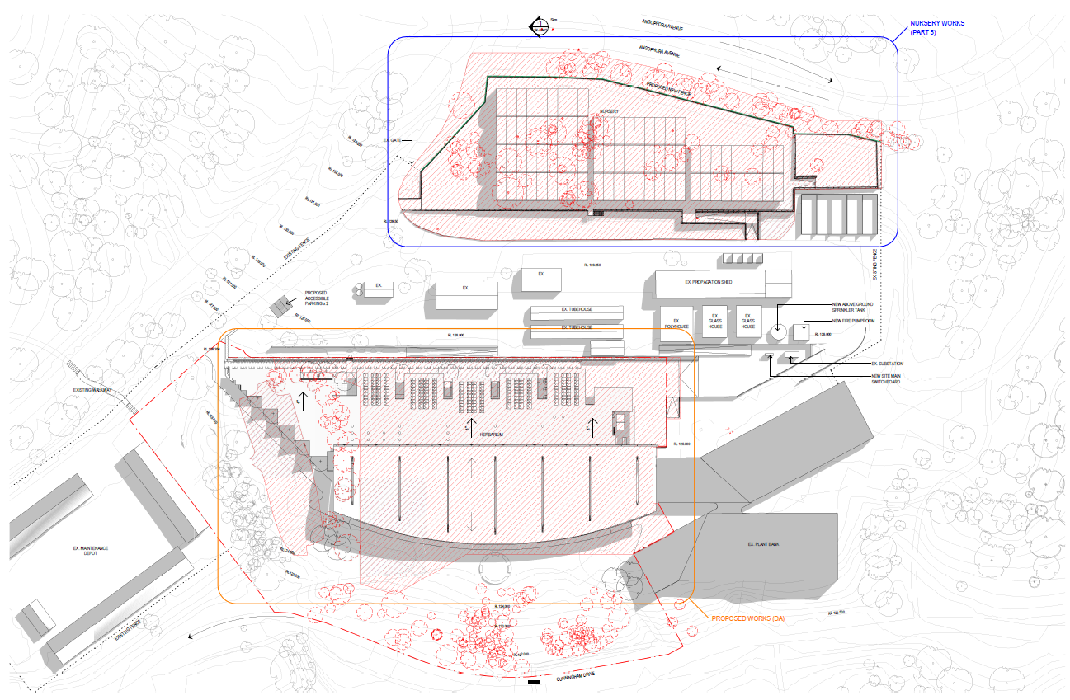

ASSESSMENT

Environmental Planning and Assessment Act 1979 - Section 4.15(1)

In determining a DA, the consent authority is to take into consideration such of the following matters as are of relevance to the development the subject of the DA:

(a)(i) the provisions of any environmental planning instrument

The environmental planning instruments that apply to the development are:

- State Environmental Planning Policy (State and Regional Development) 2011.
- State Environmental Planning Policy (Infrastructure) 2007.
- State Environmental Planning Policy No 33 - Hazardous and Offensive Development.
- State Environmental Planning Policy No 55 - Remediation of Land.
- Sydney Regional Environmental Plan No 20 - Hawkesbury-Nepean River.
- Camden Local Environmental Plan 2010.

State Environmental Planning Policy (State and Regional Development) 2011 (SRD SEPP)

The SRD SEPP identifies development that is State significant or regionally significant development.

The Panel is the consent authority for this DA as the CIV of the development is $33,185,538. This exceeds the CIV thresholds of $5 million and $30 million for Council to determine the DA pursuant to Schedule 7 of the SRD SEPP.

State Environmental Planning Policy (Infrastructure) 2007 (ISEPP)

The ISEPP aims to facilitate the effective delivery of infrastructure across the State.

Land Use Definition

The development is defined as a “research station” by the ISEPP.

Permissibility

A “research station” is permitted with consent in the site’s SP1 Special Activities and SP2 Infrastructure zones pursuant to Clause 91 of the ISEPP.

Endeavour Energy (Endeavour)

The DA was referred to Endeavour for comment pursuant to Clause 45 of the ISEPP as the site contains a variety of electricity infrastructure including a switch station, pad mounted substations and underground transmission lines.

Endeavour raised no objection to the development and recommended compliance with a number of technical guidelines and requirements. A condition requiring compliance with Endeavour’s technical guidelines and requirements is recommended.

State Environmental Planning Policy No 33 - Hazardous and Offensive Development (SEPP 33)

SEPP 33 regulates hazardous and offensive development and aims to ensure that the consent authority has sufficient information to assess whether or not development is hazardous or offensive.

SEPP 33 requires Council to assess whether or not the development stores or requires the transport of dangerous goods above its screening thresholds. If any of SEPP 33’s thresholds are breached, Council must then determine whether or not the development is hazardous or offensive by considering the measures proposed to reduce the impact of the dangerous goods.

The applicant has submitted a hazardous materials and dangerous goods risk analysis in support of the DA. This analysis details the dangerous goods to be stored on the site, including flammable liquids and oxidising agents, that will be stored in two fire rated storage areas designed to comply with the applicable Australian standards. Council staff have reviewed the analysis, agree with its recommendations and are satisfied that the dangerous goods to be stored on the site will not breach SEPP 33’s screening thresholds.

A condition is recommended that requires the quantities of all dangerous goods to be transported to and from the site to be kept below SEPP 33’s screening thresholds. Should the dangerous goods quantities need to exceed SEPP 33’s screening thresholds in the future, a Section 4.55 Modification application can be lodged to assess and address the exceedance.

Based on the above, the development is not considered to be hazardous or offensive development as defined by SEPP 33.

State Environmental Planning Policy No 55 - Remediation of Land (SEPP 55)

SEPP 55 provides a State-wide planning approach to the remediation of contaminated land.

Clause 7 of SEPP 55 requires the consent authority to consider if the site if contaminated. If the site is contaminated, the consent authority must be satisfied that it is suitable in its contaminated state for the development. If the site requires remediation, the consent authority must be satisfied that it will be remediated before the land is used for the development. Furthermore, the consent authority must consider a preliminary contamination investigation in certain circumstances.

The applicant has submitted previously completed phase two detailed contamination assessments for the site together with additional testing in support of the DA. These assessments found the site to be suitable for the development from a contamination perspective. Council staff have reviewed the assessments, agree with their findings and are satisfied that the site is suitable for the development.

A standard contingency condition is recommended that requires any contamination found during construction to be managed in accordance with Council's Management of Contaminated Lands policy.

Sydney Regional Environmental Plan No 20 - Hawkesbury-Nepean River (SREP 20)

SREP 20 aims to protect the environment of the Hawkesbury-Nepean River system by ensuring that the impacts of future land uses are considered in a regional context.

The development is consistent with the aim of SREP 20 and all of its planning controls. There will be no detrimental impacts upon the Hawkesbury-Nepean River system as a result of the development. Appropriate erosion, sediment and water pollution control measures have been proposed as part of the development.

Camden Local Environmental Plan 2010 (Camden LEP)

Site Zoning

The site is zoned SP1 Special Activities (Environmental Facility) and SP2 Infrastructure (Water Supply System) pursuant to Clause 2.2 of the Camden LEP.

Land Use Definitions

The development is defined as a “research station” by the Camden LEP.

Permissibility

A “research station” is a prohibited land use in the SP1 Special Activities and the SP2 Infrastructure zones pursuant to the land use table in the Camden LEP. However, a “research station” is permitted with consent pursuant to Clause 91 of State Environmental Planning Policy (Infrastructure) 2007.

Planning Controls

An assessment table in which the development is considered against the Camden LEP’s planning controls is provided as an attachment to this report.

(a)(ii) the provisions of any proposed instrument that is or has been the subject of public consultation under this Act and that has been notified to the consent authority (unless the Secretary has notified the consent authority that the making of the proposed instrument has been deferred indefinitely or has not been approved)

Draft Environment State Environmental Planning Policy (Draft Environment SEPP)

The development is consistent with the Draft Environment SEPP in that there will be no detrimental impacts upon the Hawkesbury-Nepean River system as a result of it.

(a)(iii) the provisions of any development control plan

Camden Development Control Plan 2011 (Camden DCP)

An assessment table in which the development is considered against the Camden DCP is provided as an attachment to this report.

(a)(iiia) the provisions of any planning agreement that has been entered into under section 7.4, or any draft planning agreement that a developer has offered to enter into under section 7.4

No relevant planning agreement or draft planning agreement exists or has been proposed as part of this DA.

(a)(iv) the regulations (to the extent that they prescribe matters for the purposes of this paragraph)

The Environmental Planning and Assessment Regulation 2000 prescribes several matters that are addressed in the conditions attached to this report.

(b) the likely impacts of the development, including environmental impacts on both the natural and built environments, and social and economic impacts in the locality

As demonstrated by the assessment, the development is unlikely to have any unreasonable adverse impacts on either the natural or built environments, or the social and economic conditions in the locality.

Visual Impacts

The visual impacts of the development upon public views from outside of the site will be limited due to its significant setback within the Garden (264m from Mount Annan Drive), relatively low height, the general rise in topography towards Mount Annan Drive to the north west and screening by the relocated plant nursery and landscaping. The following perspective image and plans demonstrate the minimal extent of the development’s visual impacts:

PERSPECTIVE FROM ‘ANGOPHORA AVENUE’ PRIVATE ACCESS ROAD LOOKING SOUTH WEST TOWARDS THE HERBARIUM AND RELOCATED NURSERY

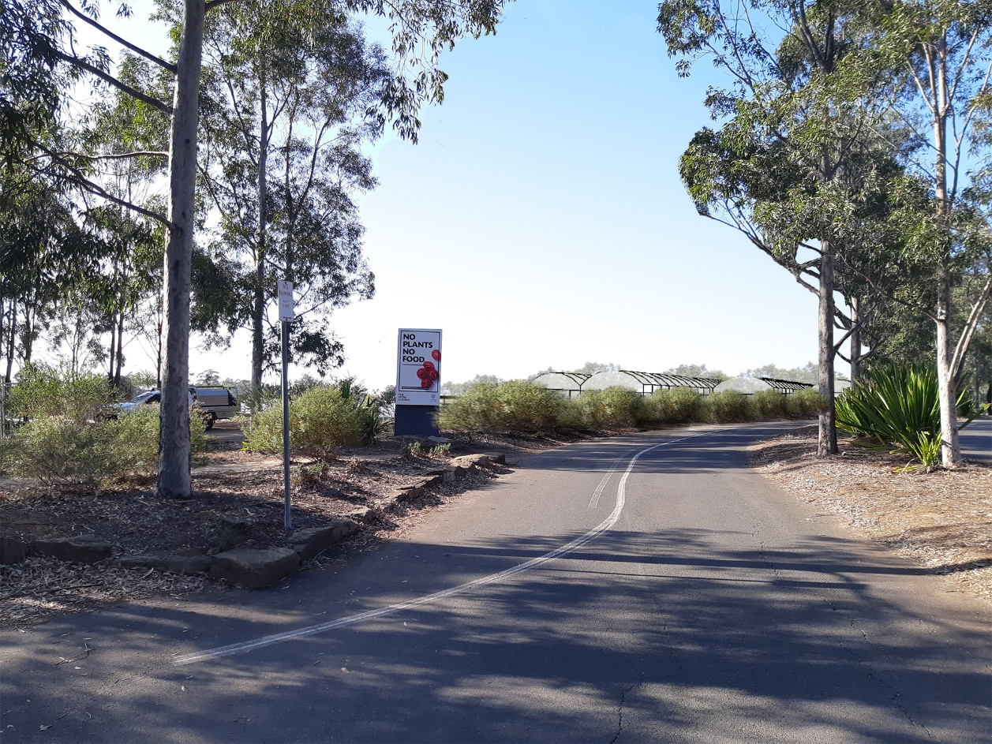

PLAN DETAILING VIEW LINES FROM ‘ANGOPHORA AVENUE’ PRIVATE ACCESS ROAD LOOKING SOUTH WEST TOWARDS THE HERBARIUM AND RELOCATED PLANT NURSERY

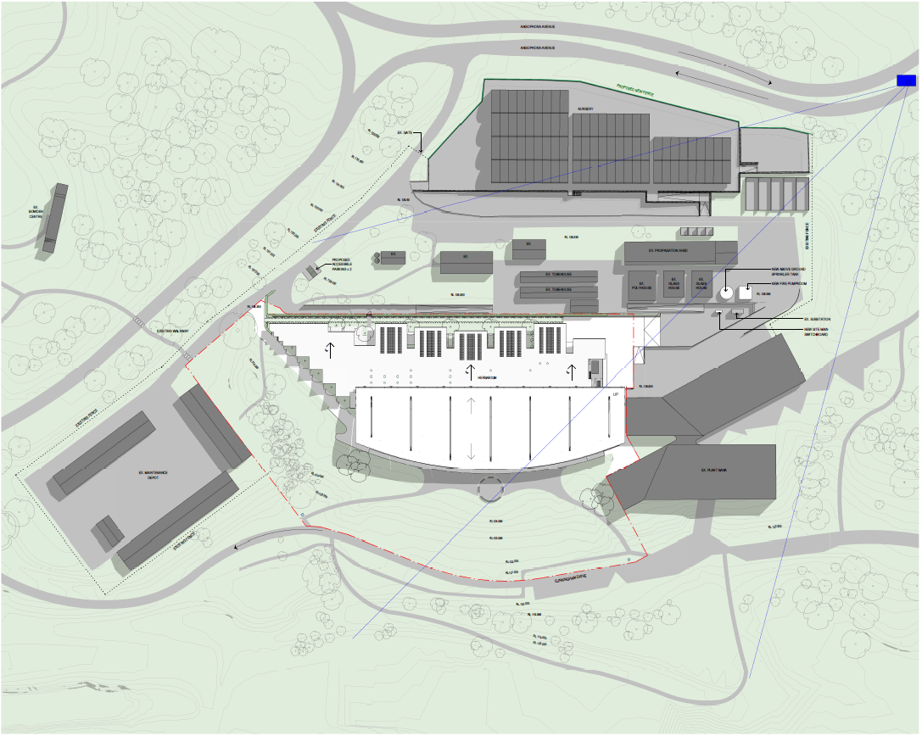

SECTION SHOWING RELATIONSHIP BETWEEN THE DEVELOPMENT, THE RELOCATED PLANT NURSERY AND ‘ANGOPHORA AVENUE’ PRIVATE ACCESS ROAD

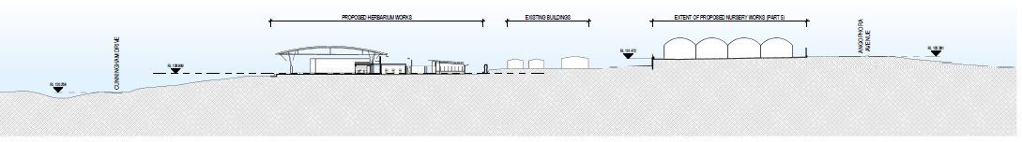

The visual impacts of the development upon views from inside the site are considered to be acceptable. The development has been designed to reflect plant life with the vaults being envisaged as seeds encapsulated and protected by a ‘pod-like’ roof structure. The contemporary materials and finishes are considered appropriate and both them and the proposed landscaping are compatible with the existing Australian PlantBank facility directly to the north of the development. It is considered that the development will have positive visual impacts upon views from inside the site and represents an improvement over the existing plant nursery structures.

PERSPECTIVE OF THE DEVELOPMENT ALONG THE EASTERN PUBLIC PLAZA

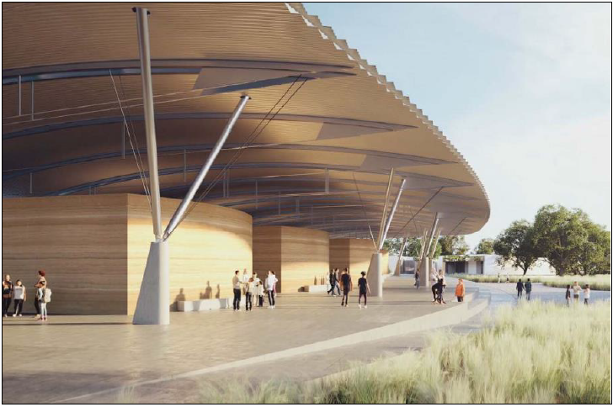

Off-Street Car Parking

The applicant has submitted a traffic impact assessment in support of the DA which considers off-street car parking provision. The development includes the demolition of an existing 41 space car park adjoining the southern boundary of the existing plant nursery. The development will provide two accessible car parking spaces near the western side of the building. Council staff have reviewed the assessment and support the proposed car parking arrangements based on the following rationale:

- the Camden DCP does not provide an off-street car parking rate for research stations and requires that they are assessed on their merits,

- the site contains four car parks with a total of 256 car parking spaces that will be in close proximity to the development,

- the development will employ 60 staff. A car usage to staff ratio of 1:1 has been assumed which is appropriate given the isolation of the site from public transport options,

- the development will generate a demand for 60 car parking spaces, and as it will also demolish an existing 41 space car park, the net car parking space demand is therefore 101 spaces,

- the applicant has provided an assessment of the usage of the four existing car parks and determined that during weekdays those car parks would have a total spare capacity of approximately 121 car parking spaces. This is more than sufficient to cater for the 101 net car parking space demand from the development,

- the likely spare car parking capacity during weekdays is concurred with as the peak visitor days for the Garden is weekends. This is confirmed through the local experience of Council staff,

- it is recognised that the spatial isolation of the site means that any overflow car parking demand will not impact upon the surrounding public road network or adjoining properties. The site also contains a number of grassed areas which could be used to informally accommodate overflow car parking should the need arise, and

- the Garden is a natural area specifically set aside for recreation, tourist, research and conservation purposes. It is considered to be in the best interests of the site to minimise the extent of at-grade car parks to only what is absolutely necessary. The construction of additional at-grade car parks should therefore be avoided where possible and justifiable (such as in the subject case).

Biodiversity Conservation Act 2016

The Camden LGA is designated as a “Western Sydney Interim Designated Area.” This means that the legislation that applied prior to the gazettal of the Biodiversity Conservation Act 2016 applies to the Camden LGA for all applications lodged before 25 November 2019. The previous legislation was the Threatened Species Conservation Act 1995. Council staff have assessed the development and are satisfied that it will not have a significant impact upon any threatened species. It is noted that the development is largely confined to an existing hardstand area occupied by an existing plant nursery and that no tree removal is proposed by the DA.

(c) the suitability of the site for the development

As demonstrated by the above assessment, the site is considered to be suitable for the development.

(d) any submissions made in accordance with this Act or the regulations

The DA was publicly exhibited for a period of 30 days in accordance with the Camden DCP. The exhibition period was from 21 August to 19 September 2019. No submissions were received.

(e) the public interest

The public interest is served through the detailed assessment of this DA under the Environmental Planning and Assessment Act 1979, the Environmental Planning and Assessment Regulation 2000, environmental planning instruments, development control plans and policies. Based on the above assessment, the development is consistent with the public interest.

EXTERNAL REFERRALS

The external referrals undertaken for this DA are summarised in the following table:

External Referral | Response
Heritage Council of NSW. | No objection and general terms of approval granted.
Endeavour Energy. | No objection and compliance with technical guidelines and requirements recommended.
Water NSW. | No objection and recommendations made regarding works within and adjacent to the Upper Canal property.
Sydney Water. | No objection and conditions recommended.
Camden Police Area Command. | No objection.

A condition that requires compliance with the general terms of approval and external referral recommendations is recommended.

FINANCIAL IMPLICATIONS

This matter has no direct financial implications for Council.

CONCLUSION

The DA has been assessed in accordance with Section 4.15(1) of the Environmental Planning and Assessment Act 1979 and all relevant instruments, plans and policies. The DA is recommended for approval subject to the conditions attached to this report.

RECOMMENDED
That the Panel approve DA/2019/573/1 for a new National Herbarium of NSW at 362 and 396 Narellan Road, Mount Annan subject to the conditions attached to this report.

